Planeswalker

Technical Documentation

Keywords:

Fog
Hauberk
Optimization
Kanban
Update
Draw
Proyect
Summary
Pattern
Factory
GameManager
Workflow

Summary:

This document explains the technical properties of the product “Planeswalker” as it also does with our chosen algorithmic procedures, optimization iterations and the different patterns and strategies used for the game’s correct and efficient development. Used external and administrative tools will also be pointed out, such as Kanban, and technical like programming libraries.

Summary:

The document will be arranged as follows:

- Team organization and game description
- Administrative and auxiliary tools
- Technical tools
- System structure and it’s documentation
- System workflow and design patterns
- Algorithms and techniques applied
- Source code refactoring and optimization
- Conclusion
- Future considerations and additional features
- References
- Special thanks

Team organization and Game description

Planeswalker is a dungeon crawling game ( https://en.wikipedia.org/wiki/Dungeon_crawl ) in which the player must accumulate points by eliminating enemies and collecting gold.
Maps are procedurally generated, enemies and objects are randomly placed, which adds replay value by making every game session unique. This project's objective was to make a simple game with little resources spent feel fresh every time it’s played, highlighting the saying “to do a lot with so little” and show that you don’t need lots of resources but ideas and determination.
The work Team:

Martín Rios: in charge of initial system design, structure development and workflow. He developed every manager and game factory and also the bullet system, also applied numerous system optimizations to increase the framerate in less powerful computers.

Ignacio Oliveto: in charge of the map’s procedural generation and it’s objects. Created TileMap, Tile and TileEvent and their integration with the system, also created and implemented the Fog of War and FOV (Field Of View)

Gonzalo Montaña: in charge of integrating pygame into the system and placement of various tools to make everything possible. Created the Character class, it’s movement and interactions with the map, also provided and implemented graphical and sound resources.

All three were in charge of the app’s testing, not only unit tests of their own code, but also to try and test every released version in our own computers, doing stress tests if possible.

Administrative and Auxiliary tools

We utilized multiple external tools to develop the entirety of this project to ease the coordination of the work for later integration. They are, as listed here:

Discord: it’s an online comunication program which was used as for discussing the game’s content and to get each others help when needed, we also checked how we we’re doing, to transfer temporal or auxiliary files and as research reference.

Trello.com: to implement Kanban methodology, we utilized Trello. Between every option available we thought that it was the most efficient and simple, aside from being extremelly intuitive and user friendly, especially for us that never implemented Kanban on another Project. Here’s the link to the website and our Lists: https://trello.com/delfoswaysoftware

OpenOffice Writer: it’s the text processing program in which we’re writing this document, aside from being the most efficient compared to similar Microsoft products, it’s free to use and it's Open Source.

Technical tools

We use a group of technical tools to carry out our work, both for the control and security of the project as well as for integration of the Python language. We proceed to list them below:

Python 3.6.2: It is the language assigned for the development of this project. We use the mentioned version since it is the newest and more community-accepted.

Pygame : The game library assigned to develop the project. At the end of the day this was the only library used for the game, and all the development of it is built on this library (Character, Tile and Bullet are subclasses of pygame.sprite.Sprite for example!)

PyCharm 2017.2.3: It is the IDE that we decided to use to work with Python. We considered multiple options, including Notepad++, SublimeText and LiClipse, but none were close the one we chose, not in elegance, simplicity or efficiency.

GitHub Desktop: Graphical interface to communicate with GitHub and use its API. It is the most comfortable and direct program that we found, in addition to having the extreme comfort of being developed exclusively for GitHub, which saved us a lot of procedures when it comes to linking and testing. This is the only program we use to perform all Git tasks (Commit, Push, Pull, Revert, Etc)
Github Link: https://github.com/delfosway/testSDL

DIA : Tool to generate different diagrams. We use this tool to perform the Class Diagram (UML) of the project structure.

System’s structure and it’s documentation

We decided to use the Object Oriented paradigm as an approach to the design of this system, since it is more familiar and elegant when organizing the structure of a system. To structure the system, we previously designed a Class Diagram, from which we work the implementation.
This diagram is located in the Technological Documentation folder and can be observed next:

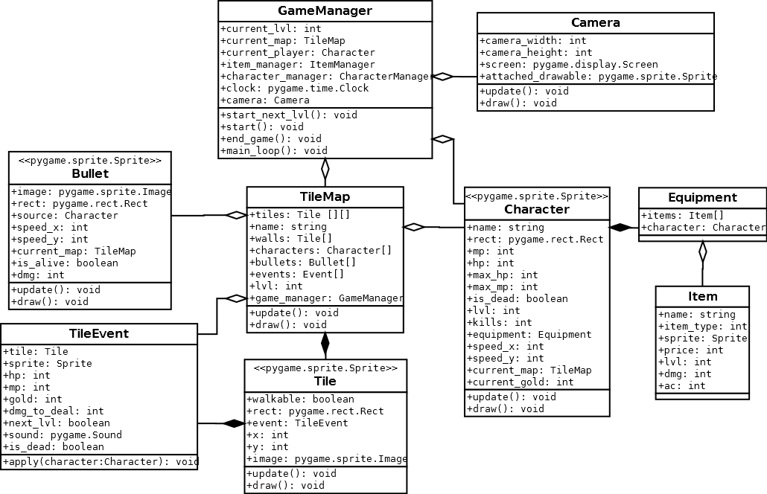

We decided to make a main structure called GameManager, which is responsible for managing the workflow of the application. This GameManager is the one that stores the player, the current map, the current level and is the one that stores all the other auxiliary Managers (ItemManager, CharacterManager) as well as the Clock and Camera.

Design patterns and system workflow

As design patterns, we chose to use the Factory ( https://sourcemaking.com/design_patterns/factory_method ) for the generation of Tiles, Characters and Tile_Events and in turn these generators work with the Object Pool Pattern ( https://sourcemaking.com/design_patterns/object_pool )

The TileMap also works as a Tile Factory and TileEvents, and the CharacterManager functions as a Factory of Characters.

Each manager has a method to get a specific object or a random object of its corresponding type (get_random_character(), get_random_tile ()) and instead of creating a new object, they have a pool of available options and generate a copy of them every time they want to return it, thus avoiding integrity problems and increasing efficiency.

Each visible object in the Game (Character, Tile, TileEvent and Bullet) has an update () method (in which its data is updated) and a draw () method (which draws that object on screen), are called once per frame. This structure is very common in graphic game design and is adopted by many popular game engines (Unity, Godot and AGS to name a few).
This framework in conjunction with the GameManager are the backbone of the system.

The system workflow is defined and manipulated through the GameManager, and is developed as follows:

start (): This method initializes all the necessary values ​​to start playing, see Camera and Player, and starts showing the Menu and Tutorial.

main_loop (): This is the main loop of the game and the core of it. Here the workflow logic of the part of the game itself is executed. This method constantly iterates by updating and drawing the corresponding objects as well as validating defeat conditions to conclude with the cycle. This cycle basically derives to the methods of update () and draw () of the relevant objects to make the game work.

end_game (): Once the player dies, the game ends and this method shows the final screen (Death summary and points) and takes the user back to the main menu.

Algorithms and utilized techniques
To develop this videogame we use several techniques, some traditional or devised by us and some external resources given the complexity and not to try and reinvent the wheel.

For the generation of random maps we used a variation of the Hauberk Algorithm (Named for the game in which it was implemented). The same can be seen in the following link: http://journal.stuffwithstuff.com/2014/12/21/rooms-and-mazes/

Our algorithm uses the same initial premise: It generates rooms in random positions and random size (within certain limitations) but instead of generating paths a posteriori, we make the generation of rooms VERY dense (more than 10000 iterations) and then we fill in the remaining spaces with walkable ground, which creates a dungeon feeling. This can be seen in the "DungeonGenerator.py" module. This generator receives a Width and a Height, generates the map and returns it in the form of a Matrix of Integers (0 = Floor, 1 = Wall) and then the TileMap object translates it to its Native structure (A Matrix of Tile objects).

For the drawing of the objects on the screen and the HUD we decided to implement a camera, a very common concept and used in graphic libraries, and implemented it very simplistically, giving it an X and a Y, and assigning an Offset (in X and Y) for the drawing of objects. This camera in turn has a method that allows you to "attach" or cling to a Sprite and follows it in each update, effectively making the camera follow the player.

To simulate the Fog Of War we implemented a validation algorithm in the draw_sprite () function of the camera.
From there we calculate the distance between the object to draw and the center of the camera (the player) and see if it is within the field of vision of the character and will only be drawn if this object is within said area. We implement it by iterating in a group of tiles around the character to limit the field, and then individually evaluating the distance between each tile and said object to draw.
The position of objects that were not drawn will be black (Background color), effectively falling out of the player's range of vision.

Source code refactoring and optimization

Throughout the development of the system we came across different setbacks and drawbacks that forced us both to optimize our algorithms or to refactor the code to sort the code structure.

The first instance of refactoring was in the first merge, which made our programming styles collide and made us decide that we needed to get together to rearrange the code to something more good looking and to better denote the workflow.

After that, the code remained fairly stable, except for some small refactorings in the most complex algorithms (i.e, random generation of Dungeons).

The next problem happened when porting the program to the Notebook in which we wanted to expose it: We did not take into account that the performance of the computer was much lower than our desktop computers, and we came across a very low performance and framerate, which made the game literally unplayable.
At that point, we took a couple of hours optimizing code and drawing routines until we reached a framerate similar to our computers. The optimizations were as follows:

- Fog Of War area dimensioning: In the initial version of the Fog of War, the distance of drawing against each of the tiles on the map was checked, which, given the size of the map (64 * 64 = 4096), required performing 4096 validations, many of which were in vain since the vast majority of those tiles were undoubtedly out of the range of view (Given the size of the camera). We solved it by adding an initial dimension of ({Vision Radio} / {Tile Size} + 2) in both X and Y, by delimiting (both with surplus units for security) the area of ​​comparison, reducing from 4096 validations to approximately 64.
This had a huge impact on game performance.

- Elimination of redundancies in movement of the Bullets: The method of movement of the projectiles had a redundancy, due to an analytical error the projectile validated the movement 2 times and when shooting many projectiles this redundancy was translated as a significant loss of frames. Having found this and having eliminated this redundancy the game returned to run efficiently.

Conclusion

We managed to create a simple but fun videogame, with many procedurally generated mechanics, which guarantees that every time one starts the game it’s a different experience from the last one.

In turn, we were able to implement methodologies such as Kanban and a successful pseudo-Scrum, which provided a lot of organization throughout the construction of this project, especially considering that it was the first time we used these tools.

We were able to overcome the adversities of time and efficiency, as well as learning various techniques of game development thanks to the practice and reading online material from authors of other similar projects.

Future considerations and additional features

Here, we are going to describe some of the features that we intended to include, but for a time limit we leave them as additional considerations. Among them are the following items:

- Shops /Buying equipment: We planed to put a kind of Shop between levels with the possibility of spending the points acquired in the best equipment. Because we had a deadline we opted to leave it out, since it was not part of the backbone of the game.

- Different classes / characters: One of the ideas was to have different characters besides the Sorcerer who is now the main character, such as Warrior, Archer, Warlock, etc. This was not implemented for the same reason we didn’t implement a shop: we thought it was not essential and we could add it at a later date if we needed or had the time.

- Drops: Another idea was the possibility that enemies when dying have a chance to throw some useful object such as a potion or additional points. This we had to leave as an additional feature as well, since the player already had a way to get objects and points.

There were several ideas that we discarded at the time of design, since in estimating the time that we were going to take we seemed that it was not prudent to include them since we ran the risk of not arriving in time, given deadline with which we count to develop this project, we tried to have the core or core functionality, and separate others as additional Features in case of going faster than expected.

Referencias

Hauberk’s Dungeon Generation Algorithm: http://journal.stuffwithstuff.com/2014/12/21/rooms-and-mazes/

Dungeon Crawler: https://en.wikipedia.org/wiki/Dungeon_crawl

Factory Pattern: https://sourcemaking.com/design_patterns/factory_method

Object Pool Pattern: https://sourcemaking.com/design_patterns/object_pool

TheTerriblePogrammer Youtube channel:
https://www.youtube.com/channel/UCYpYQNHs2NN-J-UC7Pn4G5A

Sentdex Youtube channel:
https://www.youtube.com/user/sentdex

Various graphical assets:
https://opengameart.org/

Special thanks

We thank the free resource sites listed in the references for providing the assets needed to build our game, both graphics and sound, and we thank the community of www.Stackoverflow.com for providing answers to many of our questions.

